

SAVEETHA SCHOOL OF ENGINEERING

SAVEETHA INSTITUTE OF MEDICAL AND
TECHNICAL SCIENCES

DEPARTMENT OF COMPUTER SCIENCE AND ENGINEERING

LIST OF EXPERIMENTS

COURSE CODE : CSA4001
COURSE NAME : MANAGEMENT INFORMATION SYSTEM

4 Draw a UML diagram for a food ordering system Systems. The activities of the food ordering system are listed below. Receive the Customer food orders, Produce the customer ordered food, Serve the customer with their ordered food, collect payment from Customers, Store customer payment details, Order Raw Materials for food products, Pay for Raw Materials and Pay for Labour.

AIM:
To design a UML Diagram for a Food Ordering System, illustrating the interactions between Customers, Kitchen Staff, Cashiers, Suppliers, and the System in processing food orders and payments.

PROCEDURE:
• • Receive Customer Orders
- Customers place food orders through the system.
• Prepare and Serve Ordered Food
- Kitchen staff prepares food based on customer orders.
- The system tracks order status.
- Orders are served to customers.
• Process Customer Payments
- Customers make payments after receiving their food.
- The system stores customer payment details.
• Manage Raw Materials
- The system tracks inventory and places orders for raw materials as needed.
- Payments are processed for raw materials.
• Pay for Labour
- The system handles payments for staff and other labour-related expenses.

OBSERVATION:

USECASE DIAGRAM:
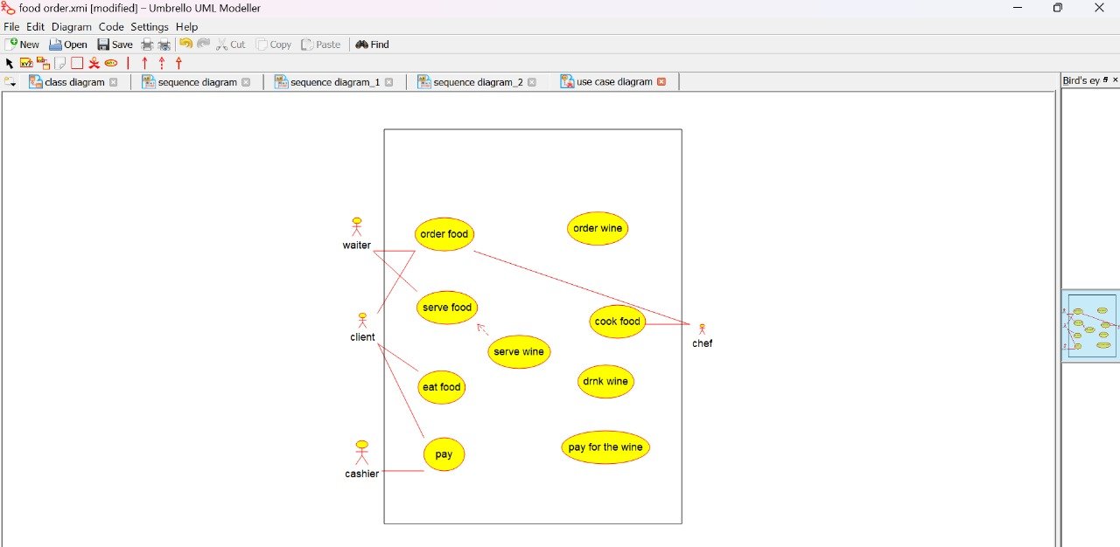

CLASS DIAGRAM:
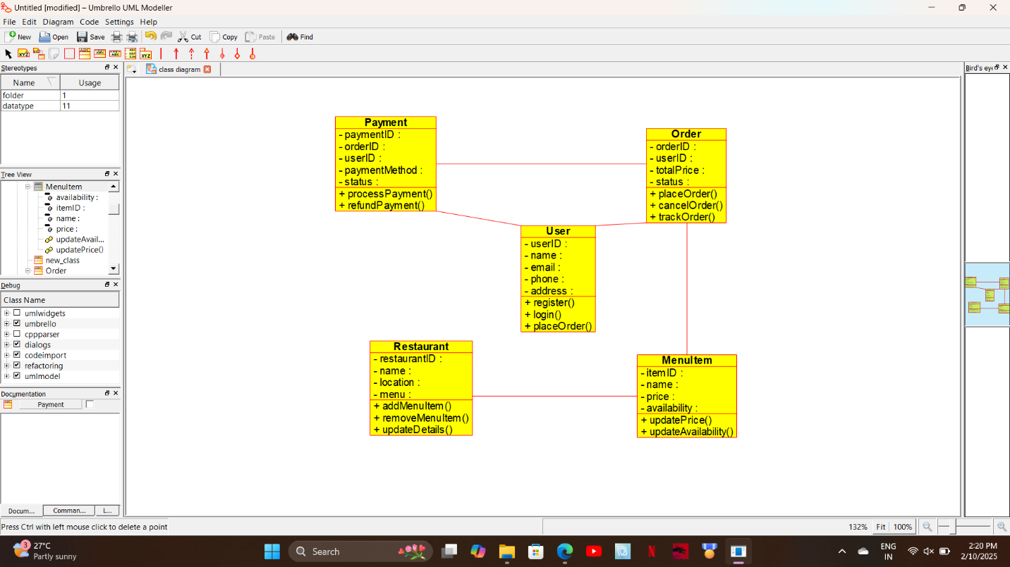

ACTIVITY DIAGRAM:
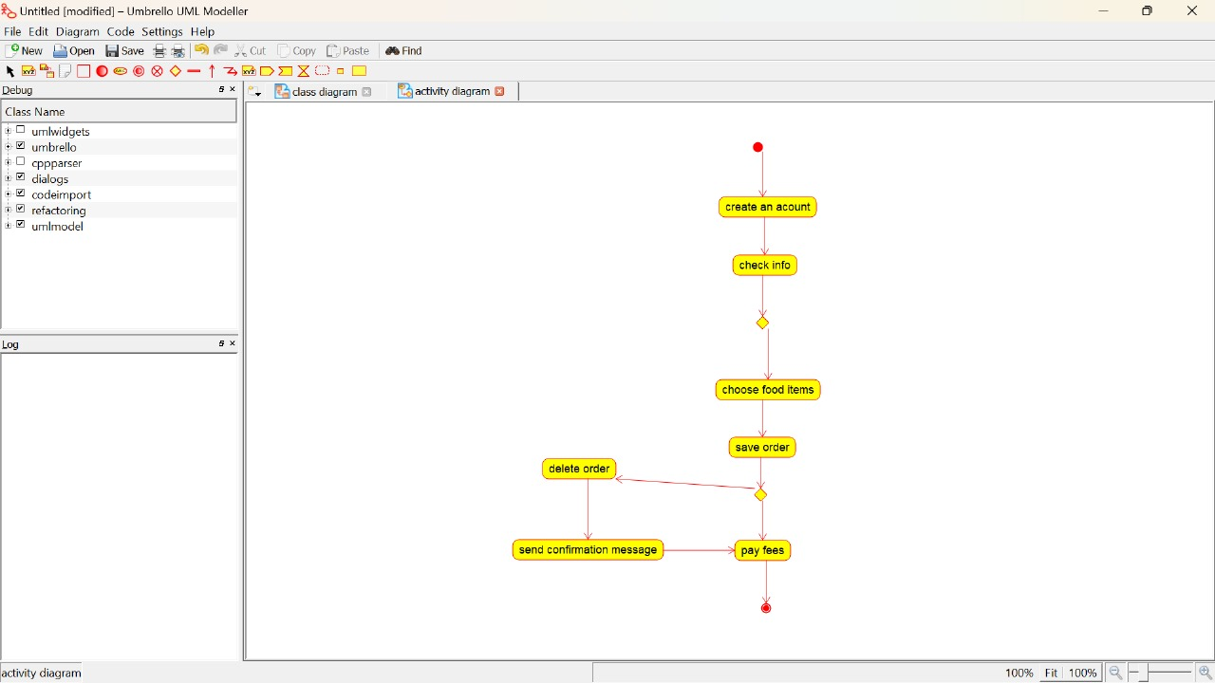

STATE DIAGRAM:
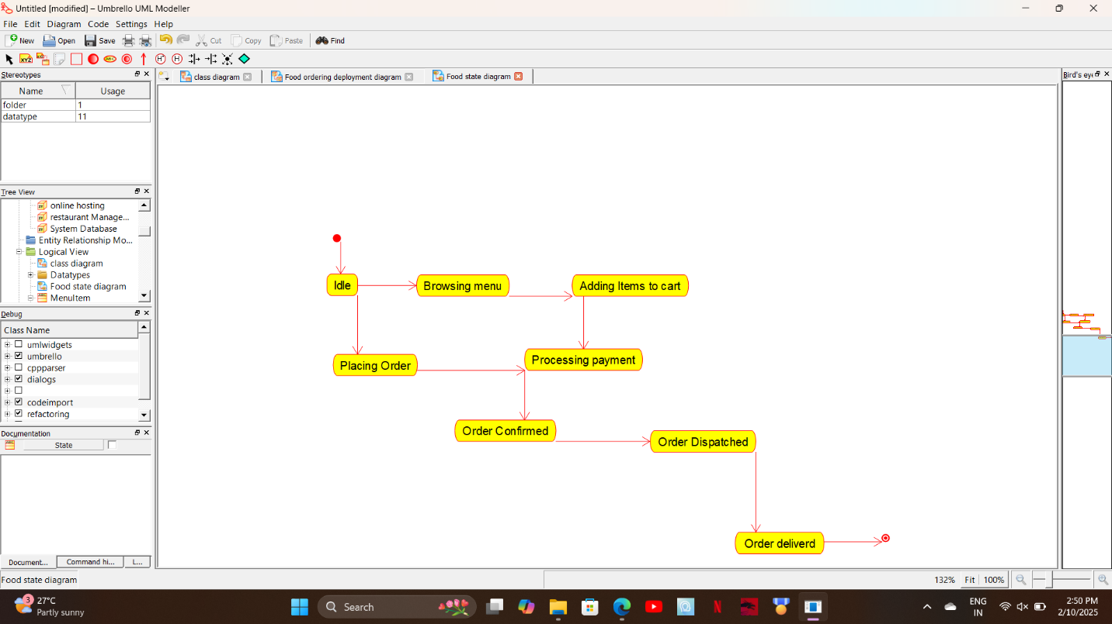

COMMUNICATION DIAGRAM:
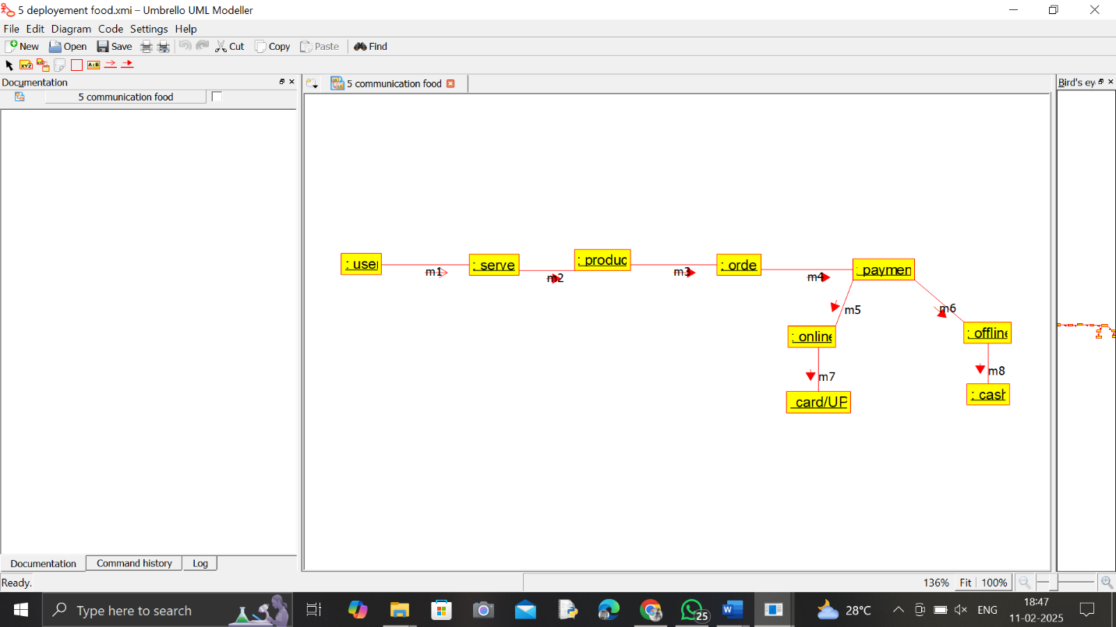

SEQUENCE DIAGRAM:
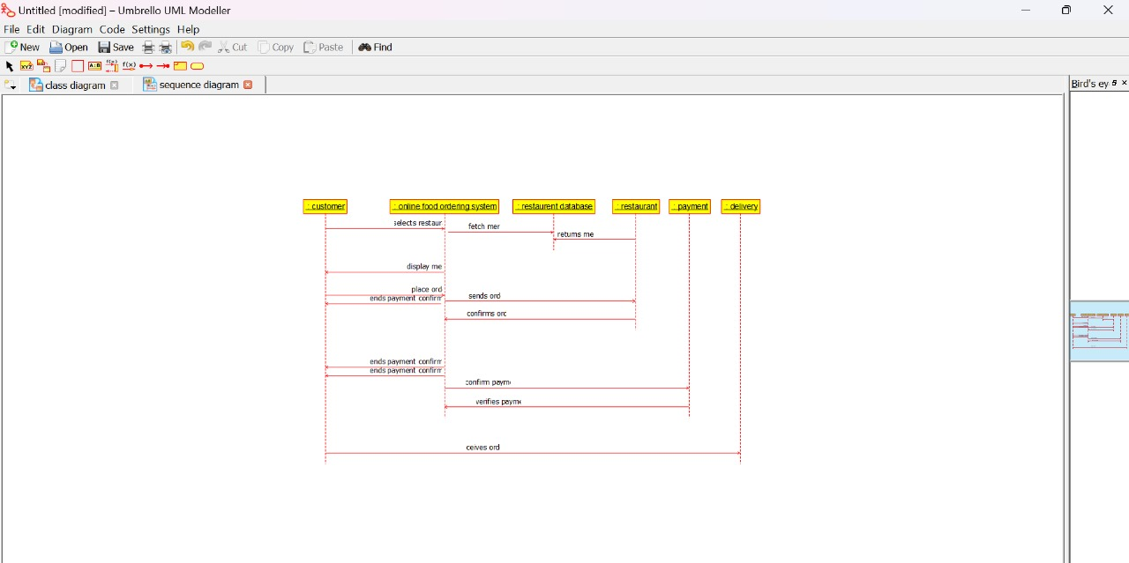

COMPONENT DIAGRAM:
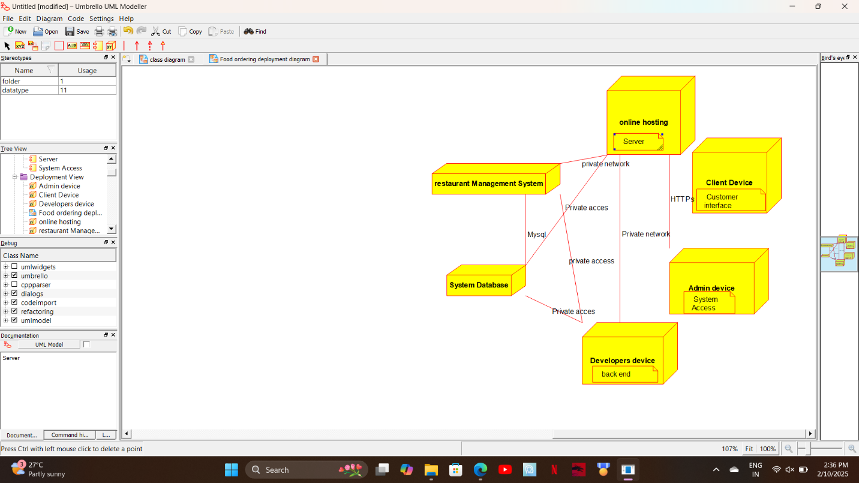

DEPLOYMENT DIAGRAM:
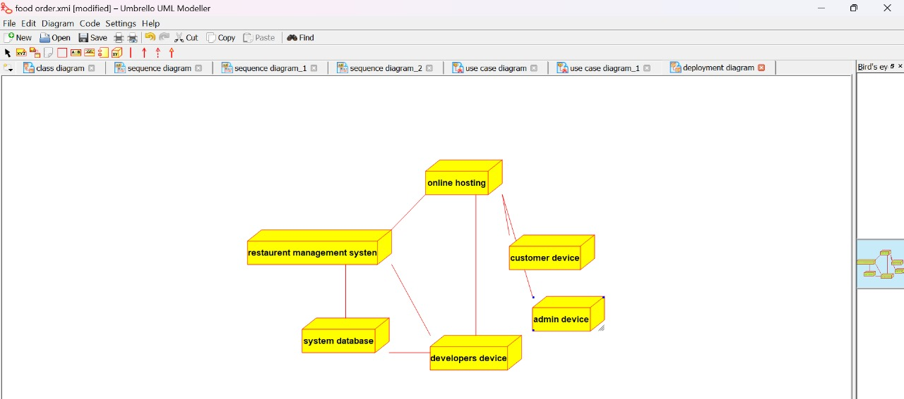

ER DIAGRAM:
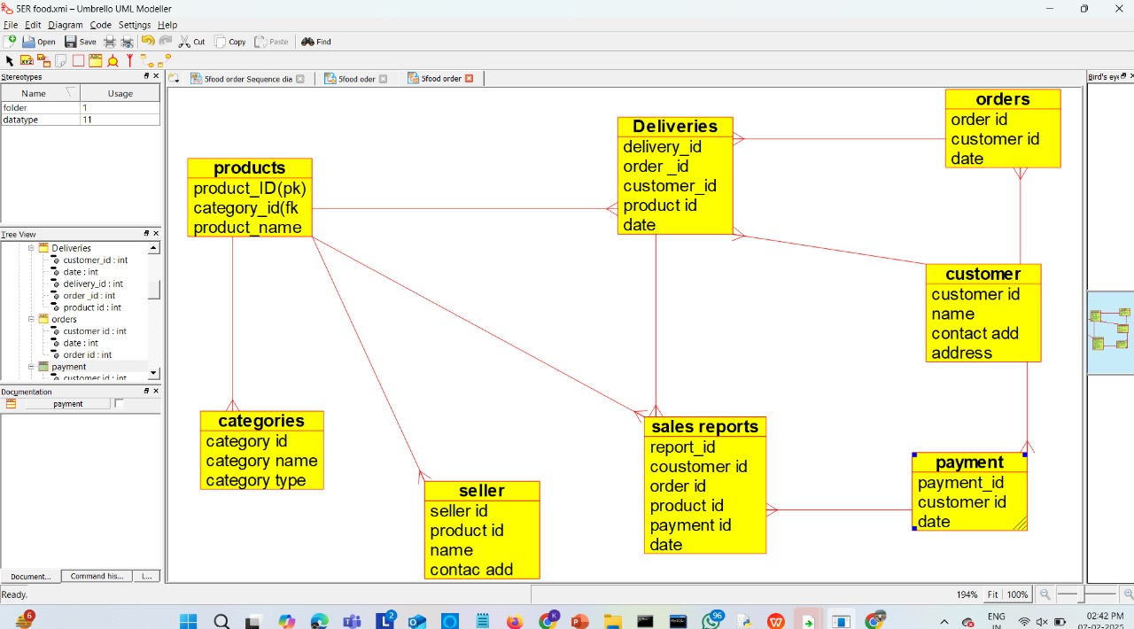

RESULT:

The UML Diagram for the Food Ordering System has been successfully created, illustrating the interactions between Customers, Kitchen Staff, Cashiers, Suppliers, and the System in food ordering and payment processes.

